EX NO: 5

09/09/2021

**SIMULATION OF GREP COMMAND AND**

**SORT COMMAND USING SHELL SCRIPTING**

**AIM:**

To write a shell program to simulate GREP and SORT command without using inbuilt functions.

**PROGRAM:**

**1)Simulation of GREP command:**

**Source Code:**

#!/bin/bash

path="/home/vijay/oslab/exp5/file.txt"

echo "Enter the pattern:"

read pattern

while read line

do

count=$((count+1))

for i in $line

do

if [[ $i = $pattern ]]

then

echo "Pattern found in line: $line"

j=$count

fi

done

done <$path

count=0

while read line

do

count=$((count+1))

if ((count==(j-1)))

then

echo "Previous line: $line"

elif ((count==(j+1)))

then

echo "Next line: $line"

fi

done <$path

**Text file content:**

1905122

Vijay Shanmugan S

BE Computer Science and Engineering

Third year section 2

**Output:**

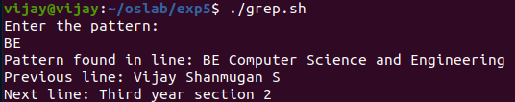

**2)Simulation of SORT command:**

**Source Code:**

#!/bin/bash

path="/home/vijay/oslab/exp5/file.txt"

while read line

do

array[$i]=$line

i=$((i+1))

done <$path

length=$i

for ((i=0;i<$length;i++))

do

for ((j=0;j<$length-i-1;j++))

do

if [[ ${array[j]} > ${array[$((j+1))]} ]]

then

temp=${array[j]}

array[$j]=${array[$((j+1))]}

array[$((j+1))]=$temp

fi

done

done

for ((i=0;i<$length;i++))

do

echo ${array[i]}

done

**Text file content:**

1905122

Vijay Shanmugan S

BE computer Science and Engineering

Third year section 2

**Output:**

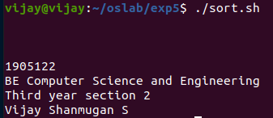

**RESULT:**

Hence a shell program to simulate GREP and SORT command without using inbuilt functions is created and the output has been verified.